TravelMate P643-M Specifications (v4-1-3)
Operating system¹ | Genuine Windows® 7 Professional 64-bit² Service Pack 1  Genuine Windows® 7 Professional 32-bit Service Pack 1  Genuine Windows® 7 Home Premium 64-bit² Service Pack 1  Genuine Windows® 7 Home Basic 64-bit² Service Pack 1
Platform¹ | Intel® Core™i7-3612QM processor (6 MB L3 cache, 2.10 GHz with Turbo Boost up to 3.10 GHz, DDR3 1600 MHz, 35 W), supporting Intel® 64 architecture, Intel® Smart Cache  Intel® Core™ i5-3210M processor (3 MB L3 cache, 2.50 GHz with Turbo Boost up to 3.10 GHz, DDR3 1600 MHz, 35 W), i5-2450M processor (3 MB L3 cache, 2.50 GHz with Turbo Boost up to 3.10 GHz, DDR3 1333 MHz, 35 W), supporting Intel® 64 architecture, Intel® Smart Cache  Intel® Core™ i3-3110M processor (3 MB L3 cache, 2.30 GHz, DDR3 1600 MHz, 35 W), i3-2370M processor (3 MB L3 cache, 2.40 GHz, DDR3 1333 MHz, 35 W), supporting Intel® 64 architecture, Intel® Smart Cache  Mobile Intel® HM77 Express Chipset
Memory^{1, 3, 4} | Dual-channel DDR3 SDRAM support:  - Up to 4 GB of DDR3 system memory, upgradable to 8 GB using two soDIMM modules⁵ (for 64-bit OS)  - Up to 2 GB of DDR3 system memory, upgradable to 4 GB using two soDIMM modules⁶ (for 32-bit OS)
Display | 14" HD 1366 x 768 resolution, Acer ComfyView LED-backlit TFT LCD  Mercury-free, environment-friendly  Super-slim design
Graphics | Intel® HD Graphics 4000 with 128 MB of dedicated system memory, supporting Microsoft® DirectX® 11, OpenGL® 3.1, OpenCL™ v1.1  Dual independent display support  16.7 million colors  External resolution / refresh rates:⁷  - VGA port up to 2048 x 1536: 75 Hz  - HDMI® port up to 1920 x 1080: 60 Hz  MPEG-2/DVD decoding  WMV10 (VC-1) and H.264 (AVC) decoding  HDMI® (High-Definition Multimedia Interface) with HDCP (High-bandwidth Digital Content Protection) support.  Intel® HD Graphics 3000 with 128 MB of dedicated system memory, supporting Microsoft® DirectX® 10.1  Dual independent display support  16.7 million colors  External resolution / refresh rates:⁷  - VGA port up to 2048 x 1536: 75 Hz  - HDMI® port up to 1920 x 1080: 60 Hz  MPEG-2/DVD decoding  WMV9 (VC-1) and H.264 (AVC) decoding  HDMI® (High-Definition Multimedia Interface) with HDCP (High-bandwidth Digital Content Protection) support
Audio | High-definition audio support  Two built-in stereo speakers  MS-Sound compatible  Acer PureZone technology with two built-in stereo microphones, featuring beam forming, echo cancellation, and noise suppression technologies  Built-in digital microphone
Storage | Hard disk drive  - 320/500/750 GB or larger, with enhanced Acer DASP (Disk Anti-Shock Protection)^{1, 8}  Solid state drive  - 128/256 GB^{1, 8}  Multi-in-1 card reader, supporting:  - Secure Digital™ (SD) Card, MultiMediaCard™ (MMC), Memory Stick™ (MS), Memory Stick PRO™ (MS PRO), xD-Picture Card™ (xD)
Optical media drive | 8X DVD-Super Multi double-layer drive:  - Read: 24X CD-ROM, 24X CD-R, 24X CD-RW, 8X DVD-ROM, 8X DVD-R, 8X DVD+R, 8X DVD-ROM DL, 8X DVD-R DL, 8X DVD+R DL, 8X DVD-RW, 8X DVD+RW, 5X DVD-RAM  - Write: 24X CD-R, 16X CD-RW, 8X DVD-R, 8X DVD+R, 6X DVD-R DL, 6X DVD+R DL, 6X DVD-RW, 8X DVD+RW, 5X DVD-RAM
Webcam | Acer Video Conference,¹ featuring:  - Acer Crystal Eye HD webcam with:  - 1280 x 1024 resolution  - 720p HD audio/video recording  - Acer Video Conference Manager software, featuring Video Quality Enhancement (VQE) technology, supporting online video calls⁹  - Acer PureZone technology
Wireless and networking | WLAN:^{1, 10, 11}  - Intel® Centrino® Advanced-N 6235, 802.11a/b/g/n Wi-Fi CERTIFIED™ with Acer Nplify™, featuring MIMO technology  - Acer InviLink™ Nplify™ 802.11a/b/g/n Wi-Fi CERTIFIED™  - Supporting Acer SignalUp™ wireless technology and Intel® Wireless Display (Intel® WiDi)¹²  WPAN:¹  - Bluetooth® 4.0+HS  LAN: Gigabit Ethernet, ASF2.0, IEEE P802.3az Energy Efficient Ethernet™ (EEE)
Security | Acer ProShield Security Manager including:  - BIOS Settings: BIOS Password, Boot Order, and Import/Export BIOS Settings  - Credential Manager: Fingerprint Registration  - Pre-Boot Authentication: Fingerprint Management  - Data Protection: File Encryption & Decryption, Personal Secure Drive  - Data Removal: File Shredder  Enhanced Acer DASP (Disk Anti-Shock Protection)  Acer Bio-Protection fingerprint solution,¹ featuring Pre-Boot Authentication (PBA), computer protection  Trusted Platform Module (TPM) solution  BIOS user, supervisor, HDD passwords  Kensington lock slot
Dimensions and weight¹ | Dimensions  343 (W) x 248 (D) x 25.4/32.4 (H) mm (13.5 x 9.76 x 1.0/1.28 inches)  Weight  2.3 kg (4.92 lbs.)¹³ with 6-cell battery pack  2.48 kg (5.30 lbs.)¹³ with 9-cell battery pack
Power adapter and battery¹ | ACPI 3.0 CPU power management standard: supports Standby and Hibernation power-saving modes  Power adapter  3-pin 65 W AC adapter:  - 95 (W) x 50 (D) x 25.4 (H) mm (3.74 x 1.96 x 1 inches)  - 216 g (0.47 lbs.)¹³ with 180 cm DC cable  Battery  - 99 Wh 9000 mAh 9-cell Li-ion battery pack¹⁴  Battery life: 10 hours^{15, 16}  - 66 Wh 6000 mAh 6-cell Li-ion battery pack  Battery life: 8 hours^{15, 16}  ENERGY STAR®
Input and control | Keyboard  88-/89/93-key Acer FineTouch™ keyboard with international language support, dedicated US dollar and Euro symbol keys  Touchpad  Next-generation oversized multi-gesture touchpad, featuring three-finger press, flip and swipe, in addition to two-finger scroll, pinch and rotate  Media keys  Media control keys (printed on keyboard): play/pause, stop, previous, next, volume up, volume down  Control keys  Acer programmable key  Acer Backup key  Acer Bio-Protection fingerprint reader¹  Acer email key  Microphone mute key  Communication key
Input and output | 144-pin Acer ProDock connector  ExpressCard®/34 slot  Multi-in-1 card reader (SD™, MMC, MS, MS PRO, xD)  Three USB 3.0 ports (one port featuring power-off USB charging)  eSATA / USB 2.0 port¹⁷  HDMI® port with HDCP support  External display (VGA) port  Headphone/speaker jack  Microphone-in jack  Ethernet (RJ-45) port  DC-in jack for AC adapter
Software¹⁸ | Productivity  - Acer Backup Manager¹  - Acer ePower Management  - Acer eRecovery Management  - Acer PowerSmart Manager  - Acer ProDock Manager  - Adobe® Flash® Player 10.x  - Adobe® Reader® 10.x  - Bing™ Bar  - BookLive (Japan only)  - Evernote (except Japan)  - Microsoft® Office Starter 2010: Includes limited-functionality Microsoft® Word and Excel with advertising; no PowerPoint or Outlook. Buy Office 2010 to use the full-featured software. (except Japan)  - Microsoft® Office Personal 2010¹ (Japan only, subject to customer request)  - newsXpresso  - Norton™ Online Backup  - Windows Live™ Essentials¹  - Windows Virtual PC  - Windows XP Mode  Manageability  - Acer Office Manager  - Intel® Small Business Advantage  Security  - Acer ProShield  - Absolute® Data Protect 60-day trial  - McAfee® Internet Security Suite Trial¹⁹  Multimedia  - Corel® WinDVD¹  - NTI Media Maker^{™1}  Communication and ISP  - Acer Crystal Eye  - Acer Video Conference Manager¹  - Microsoft® Silverlight™  - Skype™  Web links and utilities  - Acer Accessory Store¹ (Belgium, Denmark, France, Germany, Italy, Netherlands, Poland, Portugal, Spain, Sweden, United Kingdom)  - Acer Identity Card  - Acer Registration  - Acer Updater  - eBay® shortcut¹ ( Australia, Austria, Canada, France, Germany, Italy, India, Ireland, Mexico, Netherlands, Philippines, Poland, Russia, Singapore, Spain, Switzerland, United States, United Kingdom only)  - Netflix shortcut¹ (Canada, Latin America, United States only)
Options and accessories | Acer ProDock  Acer MediaBay 3800 mAh 6-cell Li-ion 2nd battery pack  2/4 GB DDR3 soDIMM module  320/500/750 GB hard disk drive  9-cell Li-ion 9000 mAh battery pack  6-cell Li-ion 6000 mAh battery pack  USB optical genius mini mouse  External USB floppy disk drive  3-pin 65 W AC adapter
System compliance | Wi-Fi®  ACPI 3.0  Mobile PC 2002  ENERGY STAR®  HSF  EPEAT® Gold  GS
Warranty | One-year International Travelers Warranty (ITW)
Quality and reliability tests | Temperature and humidity  Hinge life  Weight and pressure  Acoustics  Spillage  Free drop  Shock and vibration  Electrostatic discharge immunity  Keyboard-switch life  MTBF (mean time between failures)
Windows®. Life without Walls™. Acer recommends Windows 7.
- Specifications vary depending on model.
- 64-bit software is required to enjoy the advantages of 64-bit processing.
- Shared system memory may be allocated to support graphics, depending on system memory size and other factors. Actual system memory available to the operating system will be reduced by any memory used by the graphics solution and resources required by the operating environment.
- Memory speed may vary, depending on the CPU, chipset or memory fitted.
- A 64-bit operating system is required to enjoy the ultimate performance of 4 GB or higher memory.
- 32-bit operating systems are limited to using 3 GB of the available memory.
- Resolution/refresh rates depend on display capability and color/depth settings.
- 1 GB is 1 billion bytes. Actual formatted capacity is less and may vary depending on preloaded materials and operating environment. Acer eRecovery Management utilizes up to 10 GB of the stated hard disk capacity as dedicated backup space.
- Two VQE-enabled Acer notebooks with dual-core processors are required to enjoy the exclusive benefits and added performance of VQE.
- Actual throughput may vary depending on network conditions and environmental factors such as network traffic or overhead, building construction, and access point settings.
- Acer Nplify™, a high-throughput wireless solution, delivers superior performance and reliable connections while enabling emerging voice, video and data applications. Wi-Fi CERTIFIED™, it supports Acer SignalUp™ wireless technology and is compliant with 802.11a/b/g/n standards.
- Requires an Intel® Wireless Display-enabled PC, compatible adapter, and TV. 1080p and Blu-ray™ or other protected content playback only available on 2nd or 3rd generation Intel® Core™ processor-based PCs with built-in visuals enabled. For more information, see www.intel.com/go/widi.
- Weight may vary depending on product configuration, vendor components, manufacturing variability, and selected options.
- 9-cell battery pack (for 10-hour battery life) is subject to availability.
- The listed battery life is based on MobileMark 2007® productivity mode testing with wireless on. Details of MobileMark 2007® testing are available at www.bapco.com. Battery life rating is for comparison purposes only. Actual battery life varies by model, configuration, applications, power management settings, operating conditions, and utilized features. A battery's maximum capacity decreases with time and use.
- Battery life indicated is with Acer ePower Management enabled.
- When an eSATA device is plugged in, the USB 2.0 port is unavailable.
- Bundled software may vary depending on hardware configuration, OS and regional availability.
- Trial periods vary depending on the geographic region and specifications: 365-day trial for China, Taiwan, Hong Kong and Singapore (Simplified Chinese and Traditional Chinese OS models); 60-day trial for other regions.
In a continuing effort to improve the quality of our products, information in this document is subject to change without notice. Images shown are only representations of some of the configurations available for this model. Availability may vary depending on region.
As a phenomenon known to thin-film transistors (TFTs), liquid crystal displays (LCDs) commonly exhibit a small number of discoloration dots, as so-called "non-conforming pixels." This phenomenon is a limitation of TFT LCD technology, not a product defect, and as such is not covered by Acer's warranty.
This product, except for its external cables, is free of hazardous substances and contains no PVC (polyvinyl chloride) or BFRs (brominated flame retardants). It also complies with EPEAT® Silver, RoHS, WEEE and ENERGY STAR® standards to protect the environment.
© 2012. All rights reserved.
Microsoft and Windows are registered trademarks of Microsoft Corporation. Microsoft and Windows are registered trademarks of Microsoft Corporation. Intel, Intel Core, and Core Inside are trademarks of Intel Corporation in the U.S. and other countries.
About Acer
Since its founding in 1976, Acer has achieved its goal of breaking barriers between people and technology. Globally, Acer ranks No. 2 for notebook PCs.* A profitable and sustainable Channel Business Model is instrumental to the company's continuing growth, while its multi-brand approach integrates Acer, Gateway, Packard Bell, and eMachines brands in worldwide markets. Acer designs environmentally friendly products and has established a green supply chain through collaboration with suppliers. Acer is proud to be a Worldwide Partner of the Olympic Movement, including supporting the Vancouver 2010 Olympic Winter Games and London 2012 Olympic Games. The Acer Group employs 8,000 people across the globe. Revenues for 2011 reached US$15.7 billion. Visit www.acer-group.com for more information.
* Source: Gartner data 2011.
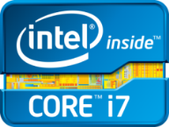 | 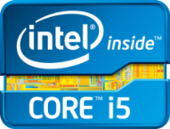 | 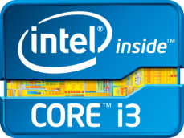 | 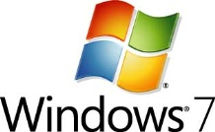 | 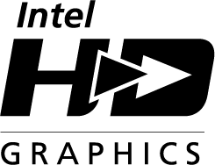
 |  |  | 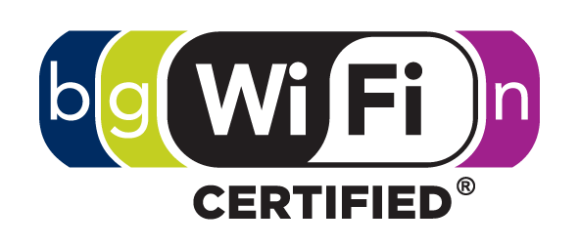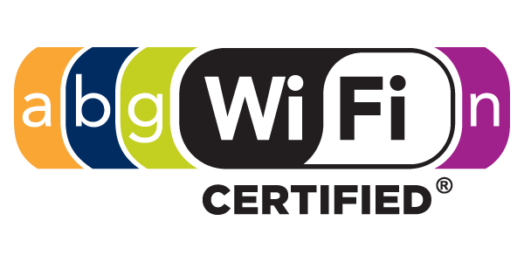 | 
 |  |  | 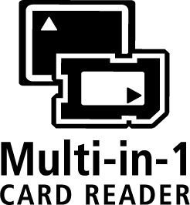 | 
 |  | 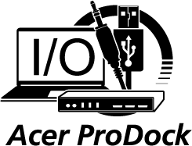 |  | 
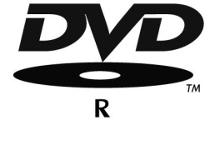 |  |  |  | 
 |  |  |  | 
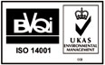 | 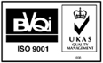 |  |  | 

